**EXPERIMENT -7**

**DML COMMANDS (COLLEGE SCEHMA)**

**AIM:**

1.Dispaly student id and marks from student table.

**code**:

**select std_no,marks from student;**

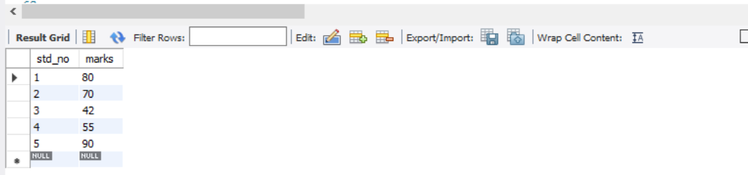

2.Dsipaly faculty id and name from faculty table.

**Code:**

**select fac_id,fac_name from faculty;**

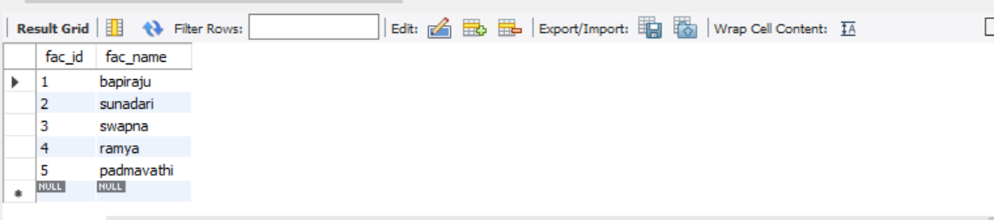

3.Display who got grade A.

**CODE:**

**select * from student where grade='A';**

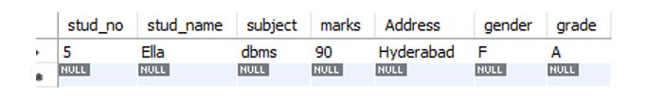

4.Display whose marks are less than 50.

**CODE:**

**select * from student where marks<50;**

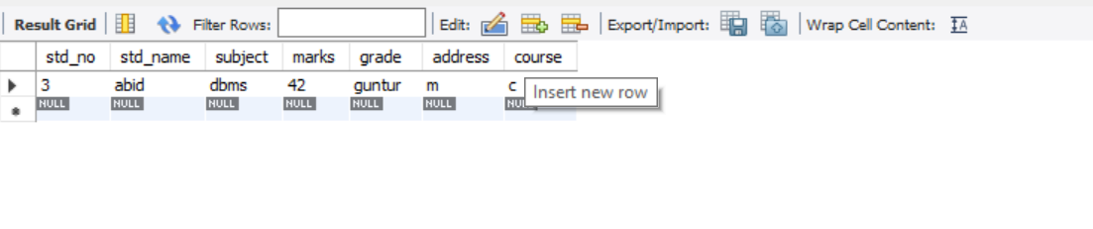

5.Display female students whose marks are between 50 to 60.

**CODE:**

**select std_no, std_name from student where marks> 50 and marks <60 and gender='f';**



6. Delete the failed students.

**CODE:**

**delete from student where marks<50;**

**select *from student;**

7. Display activity id and name using object.

**CODE:**

**select a.act_id,a.act_name from activity a;**

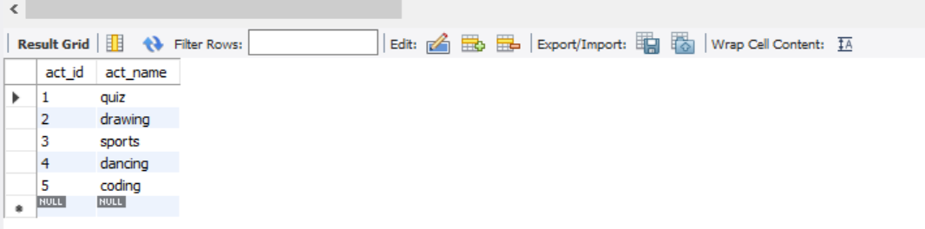

8. Display student id, faculty id using course name condition with object.

**CODE:**

**select s.stud_no,f.fac_id from student s,faculty f where s.course=f.course;**

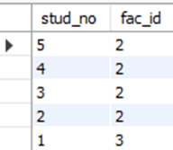

**9.** Select department name starting from ‘c’ and faculty name ending with ‘ ’.

**CODE:**

**select dept_name,fac_name from department,faculty where dept_name like 'c%' and fac_name like '%a';**

10. Select activity having characters between ‘ck’.

**CODE:**

**select * from activity where act_name like '%dm%';**

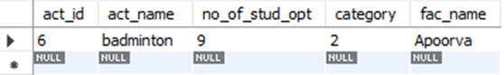

11. Group by faculty id and display.

**CODE:**

**select fac_id from faculty group by fac_id;**

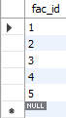

12. Display the students list whose grade is A using having.

**CODE:**

**select stud_name from student group by grade having grade='A';**



13. Display the faculty list who are teaching PPS.

**CODE:**

**select fac_name from faculty group by course having course='python';**

**14.** Apply aggregate functions in student marks - max, min, sum, count, avg.

**CODE:**

**select avg(marks), min(marks),max(marks),sum(marks),count(marks) from student;**

